servlet

References: <http://www.gravityhelp.com/documentation/page/Gravity_Forms_Documentation>

**Integration Click & Pledge Payment Gateway:**

**Requirements:** Gravity Forms requires a minimum of WordPress version 3.7+, MySQL 5 and PHP 5 in order to function properly.

**Admin login:**

**http://<your_wordpress_home>/wp-login.php**

**to log into WordPress admin area.**



After login into admin area

1. **Make sure that Gravity forms plugin installed and enabled (http://www.gravityhelp.com/documentation/page/Getting_Started)**
2. Make sure to dump all the downloaded files from github to your WordPress project plugins folder as follows.

* Copy ‘gravityforms-cnp’ folder to

<your host root>\wp-content\plugins\

* Copy ‘gravityforms/js.php’ file into

<your host root>\wp-content\plugins\ gravityforms – (It will replace the ‘js.php’ file)

Then go to ‘plugins->Installed Plugins’ enable the ‘**Gravity Forms Click & Pledge’**



1. Click on ‘Forms->Settings->C&P Payments’ to enter Click & Pledge Credentials like ‘Account ID’, ‘API Account GUID’ and to setup other settings
2. Please follow the documentation here to create a form <http://www.gravityhelp.com/documentation/page/New_Form>

**Assigning From to process through Click & Pledge:**

Click on ‘Forms->Click & Pledge’ to display all available forms.

Select the ‘Gravity Form’ to process then click on ‘Save’ button

**Setting SKU for the field**

If you want to set SKU for a product

You need to add a hidden field

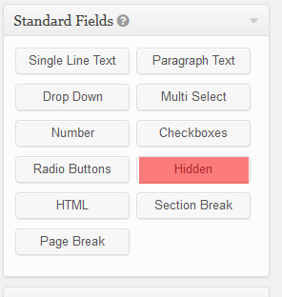

Hidden fields

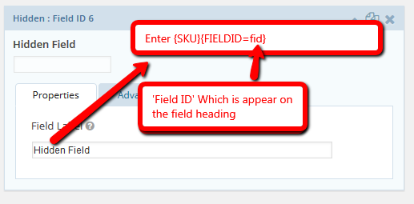

Then click on ‘Advanced;’ Button enter SKU value

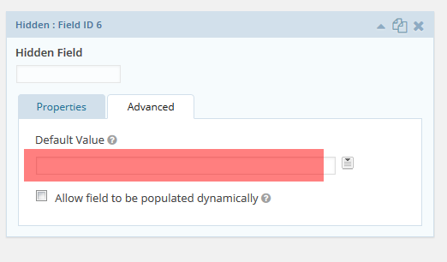

If you product is a type of ‘drop down’ or ‘radio button’

Then you need to set SKU as below

{SKU}{FIELDID=fid}{Option=value}

Here ‘fid’ is Field ID of the product

Value is ‘Label’ of the ‘Choices’